**Hypothesis 1**

Cardiac Knowledge

* H₀: There is no significant difference in cardiac knowledge scores before and after the intervention (review the website on their own).
* H₁: Cardiac knowledge scores will significantly increase after the intervention.

*This analysis will use the prepost survey data*

Histogram of pre-cardiac knowledge scores:

Histogram of post-cardiac knowledge scores:

Statistical Test:

Conclusion, since the p-value is 0.09558, because this quantity is greater than significance threshold alpha = 0.05, we don't have enough evidence to reject H0. And can conclude that there is no significant difference in cardiac knowledge scores before and after the intervention. It is important to note that there are 2 outliers in the post survey which could be skewing the results, however there are no remedial measures to minimize their effect.

**Hypothesis 2**

Healthy Eating Behavior

* H₀: There is no significant difference in healthy eating behavior scores before and after the intervention.
* H₁: Healthy eating behavior scores will significantly improve after the intervention.

*This analysis is using the pre-post survey results*

Histogram of pre-mini-EAT scores:

Histogram of post-mini-EAT scores:

Overall it appears that the pre and post results are both normally distributed.

Statistical Test:

Conclusion, since the p-value is 0.9068, because this quantity is greater than significance threshold alpha = 0.05, we don't have enough evidence to reject H0. And can conclude that there is no significant difference in Mini Eat scores before and after the intervention.

**Hypothesis 3:**

Impact of Sex at Birth on Healthy Eating Behavior Change

* H₀: There is no significant difference in pre/post change in healthy eating behavior by sex at birth.
* H₁: There is a significant difference in behavior change based on sex at birth.

*This is using the difference between post-pre scores in the pre-post survey results*

If we compare the sexes against each other:

Since the p-value is 0.04508, which is less than 0.05 we reject the null hypothesis and conclude that the sexes have different eating behaviors.

If we want to look at them separately male(pre,post), female(pre,post), we get:

As shown above each group individually do not have significantly different results because their p-values are greater than 0.05. But compared to each other, we get significantly different results.

**Hypothesis 4:**

Effect of Education Level on Cardiac Knowledge

* H₀: There is no significant difference in baseline cardiac knowledge scores based on education level.
* H₁: Baseline cardiac knowledge scores differ significantly based on education level.

*This analysis uses the pre-survey results*

From the above, based on all the pairwise comparisons, there is no significant difference between the education levels since none of the p-values are less than 0.05. Furthermore, we have normally distributed data for each of the groups as shown by the Shapiro-Wilk test, however the variance wasn't constant. Variance isn't constant because of the p value from the Levene test.

**Hypothesis 5:**

Ethnicity and Healthy Eating Behavior

* H₀: Change in healthy eating behavior does not vary by ethnicity.
* H₁: Ethnic background influences the degree of healthy dietary change through the intervention

*This uses the pre-post survey results:*

As shown above, since the p-value is 0.286, ultimately the Hispanic and Non-Hispanic or Latino groups do not have significant differences because p > 0.05. Hence we fail to reject the null hypothesis and conclude that change in healthy eating behavior does not vary by ethnicity.

**Hypothesis 6:**

* H₀: There is no significant difference in pre-intervention healthy eating behavior scores between different ethnic groups.
* H₁: There is a significant difference in pre-intervention healthy eating behavior scores between two ethnic groups.

As shown above, since the p-value is 0.724, ultimately the Hispanic and Non-Hispanic or Latino groups do not have significant differences because p > 0.05. Hence we fail to reject the null hypothesis and conclude that pre-intervention healthy eating scores do not differ between different ethnic groups.

**Hypothesis 7:**

Correlation between Cardiac Knowledge and Healthy Eating Behavior

* H₀: There is no correlation between cardiac knowledge scores and healthy eating behavior.
* H₁: Higher cardiac knowledge scores are positively correlated with healthier eating behavior.

Case 1: In the pre-intervention baseline:

Histogram of pre-intervention mini-Eat scores

Histogram of pre-intervention cardiac knowledge scores:

We can be confident that the pre mini eat and the pre-cv-quiz scores are normally distributed, they roughly follow a bell curve.

Based off the p-value of 0.2038 and the scatter plot, there isn't any significant correlation between the cardiac knowledge scores and healthy eating in the pre-intervention survey. The correlation itself is estimated to be 0.1256.

Case 2: Let’s see the same results but in the pre-post survey

Histogram of the difference of post-pre scores in the mini-EAT

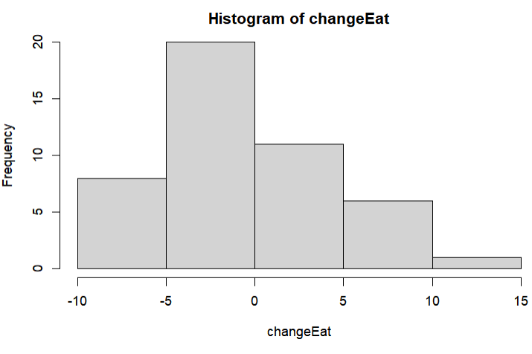

Histogram of the difference of post-pre scores in the cardiac knowledge test

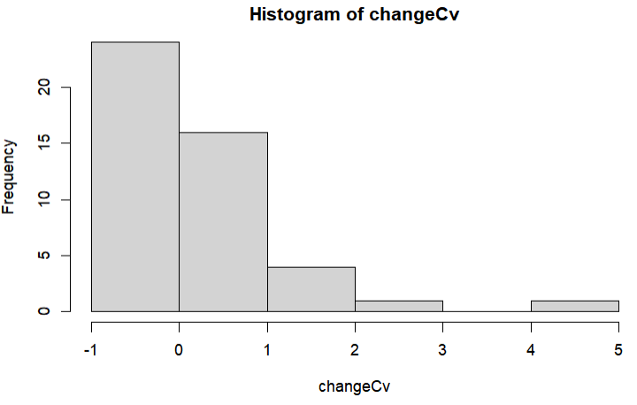

This data clearly looks skewed, but to verify, lets run the Shapiro test once again to verify the results:

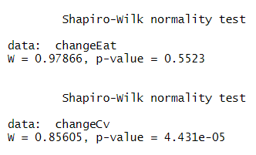

As shown above, we definitely do not have normally distributed data with the differences in the cardiovascular health variable. We will use the spearman correlation coefficient to get the correlation.

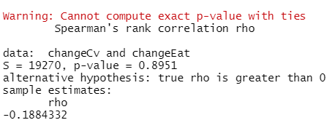

As shown above, we don't have significant correlation between the pre- and post-differences for the mini-EAT and CV score variables since the p-value is greater than 0.05.

The Anova and model summary's support the original claim that there don't exist significant linear association between the cardiovascular health and eating habit scores since the p-value is greater than alpha, as well as the plot has weak correlation.